**Part A: System Documentation**

**1. Requirements Elicitation**

**1.1 Functional Requirements**

From the elicitation session, the following functional requirements were identified:

1. **Account Opening** – The system must allow a new customer to open an account. During this process, the system must capture customer details such as first name, surname, address, and contact information (for individuals) or company information (for organizations).
2. **Account Creation** – The system must allow customers to open one or multiple accounts (Savings, Investment, or Cheque).
   * **Savings Account** – Allows deposits, earns **0.025% monthly interest for individual customers** and **0.075% monthly interest for company customers**, but does not support withdrawals.
   * **Investment Account** – Requires a minimum opening deposit of **BWP 500.00**, allows deposits and withdrawals, and earns monthly interest.
   * **Cheque Account** – Used primarily for salary deposits, allows both deposits and withdrawals, and requires employer details when opening.
3. **Deposits and Withdrawals** – Customers must be able to deposit money into all account types, and withdraw funds from Investment and Cheque accounts.
4. **Interest Calculation** – The system must automatically calculate and apply monthly interest to Savings and Investment accounts according to the defined rates.
5. **Transaction History** – Customers must be able to view past transactions, including deposits, withdrawals, and interest payments.
6. **Authentication/Login** – The system must provide a secure login for customers to access their accounts.
7. **Multiple Accounts per Customer** – The system must support linking multiple accounts under a single customer profile.
8. **Balance Inquiry** – Customers must be able to check their current balance for each account.
9. **Salary Crediting** – The system must support automatic salary deposits into Cheque accounts.

**1.2 Non-Functional Requirements**

The following non-functional requirements were identified during the elicitation session:

1. **Security** – The system must ensure that customer data is protected and only authorized users can log in. Sensitive information must be kept safe.
2. **Performance** – The system should process deposits, withdrawals, and balance inquiries quickly and without unnecessary delays.
3. **Usability** – The interface must be simple and user-friendly, making it easy for customers to navigate and perform banking operations.
4. **Availability** – The system should be reliable and available whenever customers need to access it, without downtime during working hours.
5. **Scalability** – The system should be able to handle an increasing number of customers, accounts, and transactions as the bank grows.
6. **Compliance** – The system should adhere to banking regulations and standards for customer data handling.

**2. Structural UML Modelling**

**2.1. System Use Case Diagram**

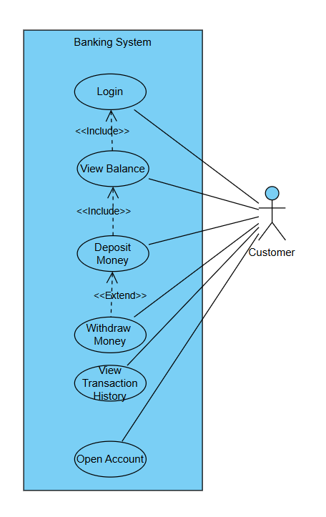

**2.2. Class diagram**

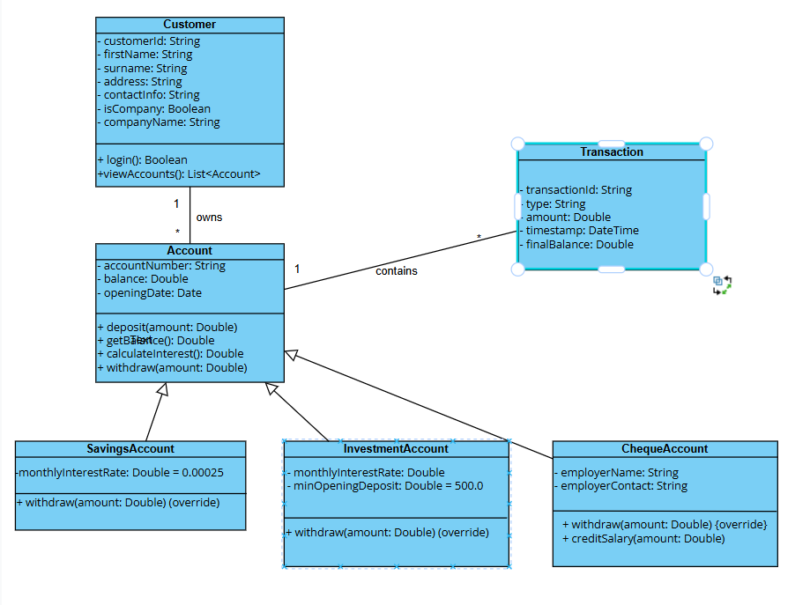

**3. Behavioural UML Modelling**

**3.1. Sequence Diagram**

**Account creation**

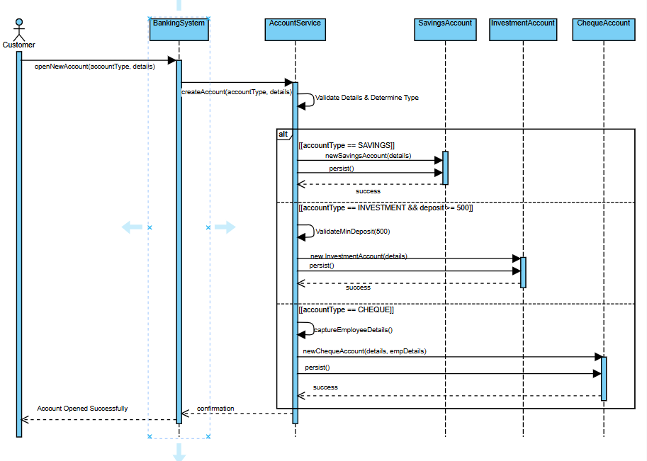

**Deposit money**

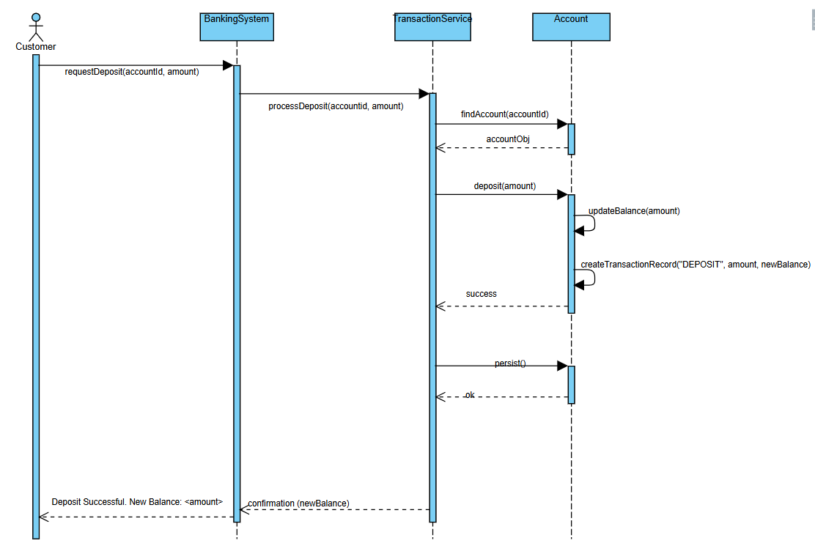

**3.2. State Diagram**

**4. Appendix: Interview Record**

**Interviewer:** Jamila Mmutle  
**Interviewee:** Kentsenao Baseki  
**Date & Time:** 18/09/2025 at 10:30am

**Q1:** Do we need to register customers before they can use the system?  
**A1:** No, we don’t separately register a customer. We open an account for a customer, and during that process, we capture their details such as name, surname, address, and contact information. For companies, we capture company information.

**Q2:** What types of accounts should the system support?  
**A2:** Savings, Investment, and Cheque accounts.

**Q3:** How should interest be handled for Savings accounts?  
**A3:** For individual customers, the savings account should earn **0.025% monthly interest**. For company customers, the savings account should earn **0.075% monthly interest**. Withdrawals are not allowed from savings accounts.

**Q4:** How should Investment accounts work?  
**A4:** Customers must open them with a minimum deposit of **BWP 500.00**. They allow both deposits and withdrawals, and they earn monthly interest.

**Q5:** What about Cheque accounts?  
**A5:** They are mainly used for salary deposits. Customers can make both deposits and withdrawals, but when opening this type of account, the employer’s details must also be provided.

**Q6:** What functions should customers be able to perform once accounts are opened?  
**A6:** They should be able to deposit money, withdraw money (where allowed), check their balance, and view their transaction history.

**Q7:** Should a customer be able to hold multiple accounts?  
**A7:** Yes, one customer can have more than one type of account.

**Q8:** Should the system support salary payments?  
**A8:** Yes, salaries should be credited directly into cheque accounts.

**Q9:** What are your expectations regarding system security?  
**A9:** The system must provide secure login and protect all customer data.

**Q10:** How should the system perform?  
**A10:** It should process deposits, withdrawals, and inquiries quickly without delays.

**Q11:** Should the system be always available?  
**A11:** Yes, customers should be able to access it whenever they need.

**Q12:** Do you expect the system to grow in the future?  
**A12:** Yes, it should scale to support more customers, accounts, and transactions as the bank expands.